Windows 10 ActiveSync quarantine error “Your device is temporarily blocked from synchronizing using Exchange ActiveSync until your administrator grants it access”.

**Symptoms**

New windows 10 users will be getting below emails from “Microsoft outlook” stating that Your device is temporarily blocked from synchronizing using Exchange ActiveSync until your administrator grants it access.

**End user might receive an email like the one below.**

**From:** Microsoft Outlook   
**Sent:** 06 March 2018 07:21  
**To:** DEFGH, ABC <[abc@pg.com](mailto:abc@pg.com)>  
**Subject:** Your device is temporarily blocked from synchronizing using Exchange ActiveSync until your administrator grants it access.

P&G EMAIL - PLEASE READ ** ACTION REQUIRED: ** This email application is not yet approved for use for P&G mail. Please use one of the following instead: Outlook for Windows PC Outlook for Mac Outlook for Android Outlook for iOS Outlook for windows mobile More details here: <http://itsolutions.pg.com/o365/Pages/OutlookMobile.aspx>

Your device is temporarily blocked from accessing content via Exchange ActiveSync because the device has been quarantined. You don't need to take any action. Content will automatically be downloaded as soon as access is granted by your administrator.

Information about your device:

|  |  |
| --- | --- |
| Device model: | 20F5S09W3U |
| Device type: | WindowsMail |
| Device ID: | 188488A3AFAA75D2204F00D8A1CD638C |
| Device OS: | Windows 10.0.15063 |
| Device user agent: | MSFT-WIN-3/10.0.15063 |
| Device IMEI: |  |
| Exchange ActiveSync version: | 16.0 |
| Device access state: | Quarantined |
| Device access state reason: | Global |

**Cause**

Windows 10 native email app (WindowsMail App ) connects to a mailbox / an email account using ActiveSync as protocol and P&G through mobility policy allows only “**Outlook for iOS and Android**” to connect via ActiveSync there by quarantining any other device trying to connect to a mailbox via ActiveSync.

## Resolution

Please Delete / Turn off email account configured in the WindowsMail App.

Steps :

1. From Mail or Calendar apps, choose **Settings** in the lower-left corner. Settings

**Note:** If you're using a phone or tablet, choose **More** More icon at the bottom of the page to see the **Settings** option.



1. Choose **Manage Accounts**, and then choose the account that you want to remove.

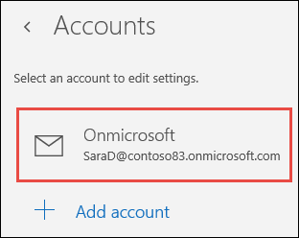

1. Choose **Delete account**. If you don't see the **Delete account** option, you're probably trying to remove the default email account added when you logged on to Windows 10. You can [turn off email from this account](https://support.office.com/en-us/article/delete-an-email-account-from-mail-and-calendar-apps-dba65c49-648d-4d76-9f88-b7bc22a2cc3d#turnoff) instead.

**Note:** The **Delete account** option removes the account from the Mail and Calendar apps, but does not affect the account itself. For example, if you remove an Outlook.com account from the Mail and Calendar apps, you can still access that account using another email client or on the web at [https://outlook.com](https://outlook.com/).

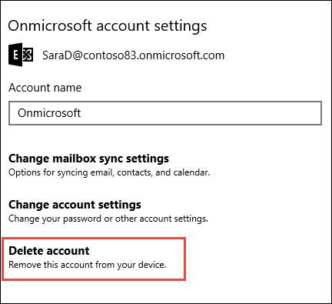

Article for reference : <https://support.office.com/en-us/article/delete-an-email-account-from-mail-and-calendar-apps-dba65c49-648d-4d76-9f88-b7bc22a2cc3d>